Hi!

I am so excited to share with you about an opportunity I have to go to <INSERT PLACE> on a mission trip this summer!

While I’m there, we’ll be <INSERT ACTIVITIES>

The biggest blessing that you can provide would be to include my team and me in your prayers. We ask that you pray for our safe travels, open hearts, the community and for each day to come with the chance to plant the seed of faith.

In addition, I am working to raise <INSERT AMOUNT> before June 30th. If you feel led to help support me, your donation will go towards our work and ministry projects.

There are 3 easy ways you can send your tax deductible gift.
- You can simply place a personal check, made payable to Launch International, in the enclosed yellow-stamped envelope, and drop it in the mail. Please include my account number <7XXX> on the memo line of the check.
- If you would rather give by credit card, PayPal, Google Pay or debit card, you can go take a picture of this QR code on your phone, and it will take you right to the donation page.
- Go to the website https://www.launchinternational.net/mission-trips. Then, select my name from the “Sub Fund drop-down box.

I can’t do it without you! Thank you in advanced for sponsoring me on my trip!

Blessings!

<YOUR NAME>
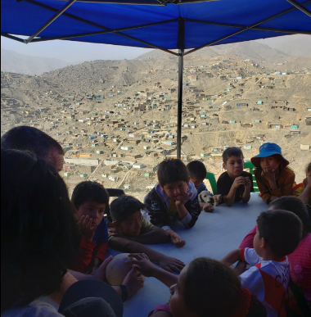
Insert a personal picture here

